Project Design Phase-II

Data Flow Diagram & User Stories

|  |  |
| --- | --- |
| Date | 03 October 2022 |
| Team ID | PNT2022TMID30135 |
| Project Name | Project - TRIP BASED FUEL CONSUMPTION PREDICTION |
| Maximum Marks | 4 Marks |

Data Flow Diagram:

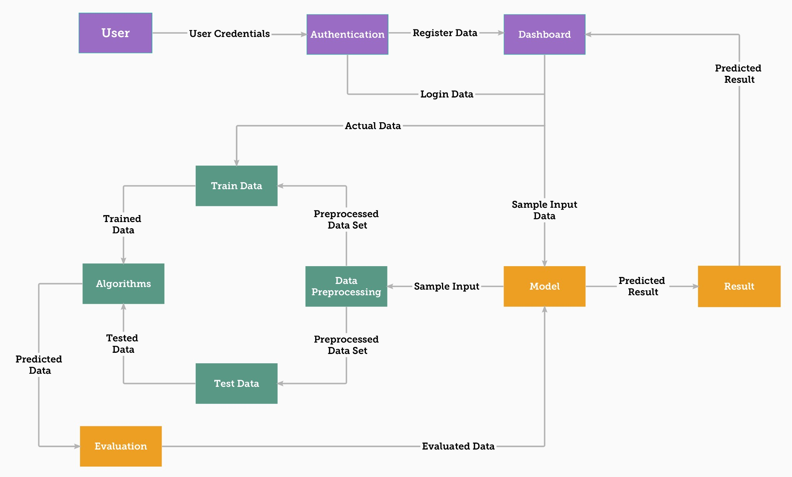

**User Stories**

|  |  |  |  |  |  |  |
| --- | --- | --- | --- | --- | --- | --- |
| **User Type** | **Functional Requirement (Epic)** | **User Story Number** | **User Story / Task** | **Acceptance criteria** | **Priority** | **Release** |
| Customer | Registration/  Login | USN-1 | As a user, I can register or  login to create a dashboard for my processing | I can access my  account / dashboard | High | Sprint-3 |
|  | Dashboard | USN-2 | Once I enter the dashboard I  can input values for a single sample prediction | I can predict for  single sample | High | Sprint-1 |
| Customer  (Organiza tion) |  | USN-3 | Once I enter the dashboard I  can input values via excel sheet for multiple sample prediction | I can perform  multiple sample prediction | Medium | Sprint-2 |
|  |  | USN-4 | As a user I can get visual  representation of the prediction | I can have different  forms of output | High | Sprint-1 |
|  |  | USN-5 | As a user I can view the  detailed report of my prediction | I can access details  of my process and prediction | Medium | Sprint-1 |
|  | Documentation | USN-6 | As a user I can refer the to  documentation for support and guidance | I can use user  manual for guidance | Medium | Sprint-1,2,  3,4 |

|  |  |  |  |  |  |  |
| --- | --- | --- | --- | --- | --- | --- |
| **User Type** | **Functional Requirement (Epic)** | **User Story Number** | **User Story / Task** | **Acceptance criteria** | **Priority** | **Release** |
| Developer | Settings | USN-7 | As a developer I can access dashboard’s settings and view the API token | I can view the API token for creating request such as predicting, downloading report,  etc., | Low | Sprint-4 |
|  |  | USN-8 | As a developer I can use the API token to send request to server | I can send request to server along with token | Medium | Sprint-4 |